Pyrrolizidine alkaloid-induced hepatic sinusoidal obstruction syndrome: Hepatopathy with hematopathy origin

HE Yisheng¹, SONG Zijing², MA Jiang³, LIN Ge³
1. School of Medicine, The Chinese University of Hong Kong, Shenzhen 518172, China
2. Zhongshan Institute for Drug Discovery, Shanghai Institute of Materia Medica, Chinese Academy of Science, Zhongshan 528454, China
3. School of Biomedical Sciences, The Chinese University of Hong Kong, Hong Kong 999077, China

Background: Hepatic sinusoidal obstruction syndrome (HSOS) is a fatal vascular liver disease characterized by liver sinusoidal endothelial cell (LSEC) injury. Exposure to pyrrolizidine alkaloids (PAs), the most common plant toxins found in herbal medicines and contaminated food products, is a leading cause of HSOS. However, why PAs specifically damage LSEC rather than initially targeting hepatocytes, as seen with other hepatotoxins such as acetaminophen, remains a long-standing puzzle. This study addresses this question from a novel hematopathologic perspective.
Methods: Protein adduction analysis was performed on both experimental animal models and clinical samples from PA-intoxicated patients. Blood protein targets of PAs were identified, and their pathological roles in LSEC damage and HSOS progression were investigated using in vitro and in vivo models.
Central Findings: PAs characteristically induced abundant protein adducts in red blood cells (RBCs) and plasma. Specifically, PA-derived reactive metabolites adducted RBC glucose-6-phosphate dehydrogenase (G6PD) and plasma haptoglobin, leading to accumulation of oxidative hemolytic products. This triggered a pathogenic cascade of LSEC activation, LSEC damage, hepatocyte ferroptosis, and HSOS development. Based on these distinct blood protein targets, an etiological therapeutic strategy was developed with translational potential.
Conclusions: PA-induced HSOS is a "hepatopathy with hematopathy origin." Targeting hematopathy, specifically PA-induced RBC damage and hemolytic product accumulation, represents a promising etiological therapeutic approach for this fatal vascular liver disease.

Acknowledgement: Project supported by National Natural Science Foundation of China (82474179), Guangdong Basic and Applied Basic Research Foundation (2024A1515011705, 2023A1515110677).
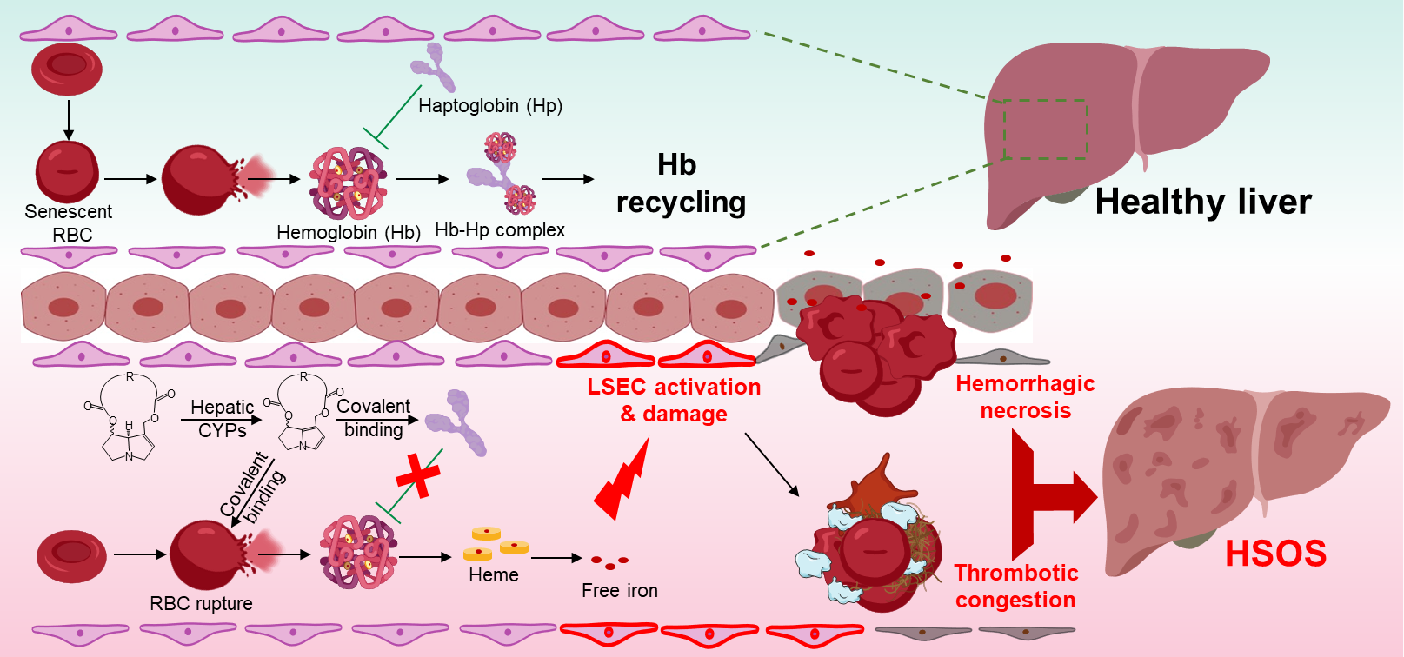Figure 1. Research hypothesis and findings: We unravel the pathogenesis of PA-induced HSOS from a new hematopathologic perspective, based on the interaction between PA-derived reactive metabolites and blood G6PD or haptoglobin. The resultant RBC rupture and accumulation of oxidative hemolytic products trigger a cascade of LSEC activation& damage, initiating the HSOS pathogenesis.
The findings delineated the mechanism underlying the unique hepatotoxic manifestation induced by PA, which provides the basis for developing etiological therapy for PA-induced HSOS.

