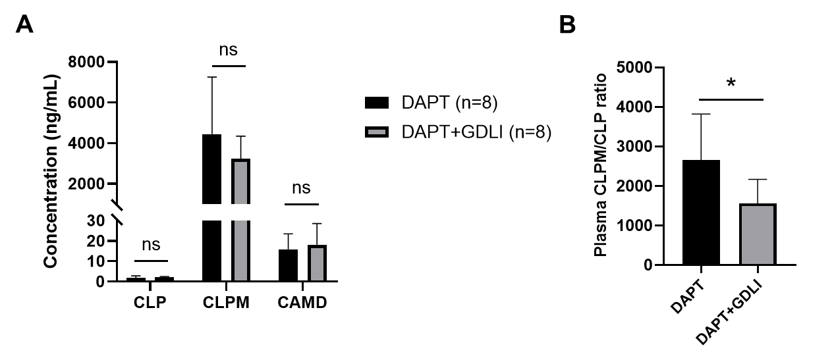
Fig. 1. Potential pharmacokinetic interaction of DAPT and GDLI in ischemic rats demonstrated via (A) the steady-state concentrations of CLP, CLPM and CAMD in plasma and (B) the ratio of CLPM/CLP concentrations in plasma. Data were presented as Mean ± SD. *p<0.05 compared with DAPT group.
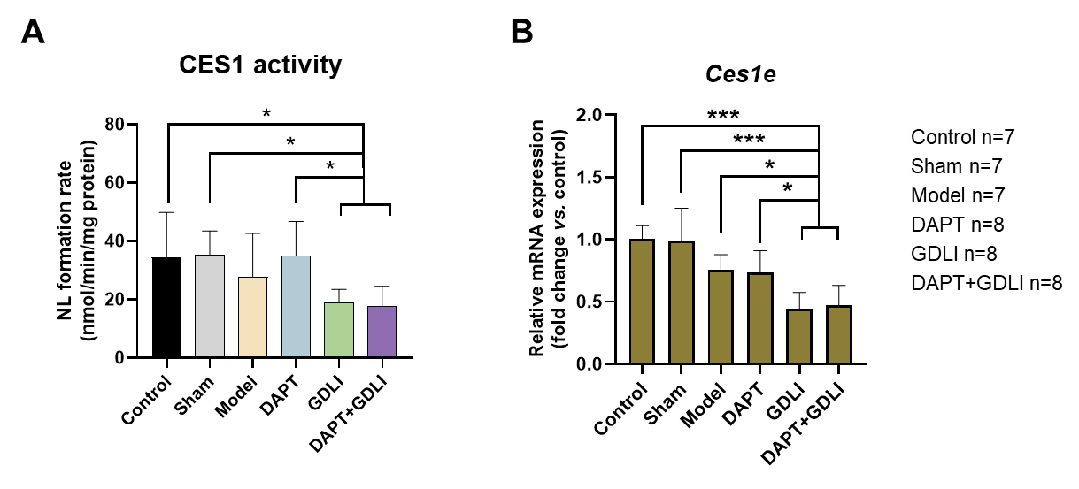
Fig. 2. Potential mechanism of pharmacokinetic interaction of DAPT and GDLI in ischemic rats demonstrated via (A) CES1 activity and (B) Ces1e mRNA expression in liver. Data were presented as Mean ± SD. *p<0.05, **p<0.01, ***p<0.001 compared with GDLI, DAPT+GDLI group.

