Evaluation of piperine nanoparticles in CGG repeat mouse model for FXTAS treatment
Jiahao Li¹, Weikang Ban¹, Sharon Shui Yee Leung¹, Ho Yin Edwin Chan^{2,3}, Zhong Zuo¹

¹Guangdong-Hong Kong-Macao Joint Laboratory for New Drug Screening, School of Pharmacy, Faculty of Medicine; ²School of Life Sciences, Faculty of Science, The Chinese University of Hong Kong; ³Gerald Choa Neuroscience Institute, The Chinese University of Hong Kong, Hong Kong SAR;

Purpose
Fragile X-Associated Tremor/Ataxia Syndrome (FXTAS) is a neurodegenerative disease caused by DNA mutation and currently lacking effective treatments to halt its progression [1]. Recent studies had identified piperine as a potential therapeutic agent for FXTAS [2]. However, its low aqueous solubility (0.04 mg/mL) [3] limited its investigations at higher doses. Our previous study successfully formulated piperine into nanoparticles with a concentration of 50 mg/mL, which demonstrated enhanced systemic exposure and brain uptake [4], enabling further evaluation of its effects in transgenic mouse model of FXTAS. Such FMR1 CGG KI model replaced the endogenous murine gene segment with the human expanded CGG repeats, driving toxic RNA expression via the native promoter, resulting in a progressive decline in both motor coordination [5, 6] and cognitive function [6, 7], allowing screening and mechanistic studies of potential drug candidates for the treatment of FXTAS. This project was designed aiming to evaluate the effects of piperine nanoparticles (PIP NPs) in CGG repeat mouse model on their behaviours and explore the possible mechanisms.

Methods
CGG repeat mice were first screening and verification by genotyping assay followed by evaluating the Maximum Tolerated Dose (MTD) of PIP NPs in CGG repeat mice. A total of 30 wildtype littermates (WT) mice (Group I) and mutant CGG repeat mice (Group II-III) aged 50~54 weeks old were assigned to orally receive vehicle (Group I & II, n=10 per group) and PIP NPs at 30 mg/kg (Group III, n=10) once daily for 9 consecutive weeks as shown in Figure 1A. According to the schematic diagram (Figure 1A), on weeks 2, 4, 6, and 8, rotarod tests were conducted, while Barnes maze tests were conducted on weeks 3, 5, 7, and 9. At the end of the behaviour tests on week 9, mice were sacrificed to collect the brain tissue for monitoring the levels of FMR1 mRNA, FMRP expression in the whole brain (n=6) and ten different brain regions (olfactory, basal ganglia, cortex, hypothalamus, thalamus, hippocampus, midbrain, cerebellum, pons, and medulla, n=3/region). In addition, the presence of ubiquitin-positive intranuclear inclusions in the ten different brain regions of mice in Group I to III were detected.
Based on the findings on FMR1 mRNA and ubiquitin-positive intranuclear inclusions, molecular docking analyses were adopted to further illustrate the underlying mechanisms related to the interactions between piperine and DHX9 (a G-quadruplex and R-loop resolving helicase associated with the FMR1 transcription) and Hsp70 (a heat shock protein that identified and promotes the clearance of ubiquitin-positive intranuclear inclusions), respectively.

Results
The 9 weeks treatment with PIP NPs resulted in significant improvements in motor coordination (p<0.05 to p<0.01, Figure 1B) and spatial memory (p<0.05 to p<0.0001, Figure 1C) compared to those in the vehicle treated CGG repeat mice. Additionally, PIP NPs treatment significantly decreased FMR1 mRNA (p<0.05 to p<0.0001, Figure 2A) and ubiquitin inclusions (p<0.05 to p<0.0001, Figure 2B), and restored FMRP expression (p<0.05 to p<0.0001, Figure 2C) uniformly across all brain regions compared to those in vehicle treated CGG repeat mice. This widespread clearance of intranuclear inclusions aligned with the brain distribution of PIP NPs observed in our previous pharmacokinetic studies [8]. Further molecular docking analyses suggested that piperine could occupy the helicase core of DHX9 to inhibit FMR1 transcription and bind to the nucleotide-binding domain of Hsp70 to enhance the identification and clearance of ubiquitin‑positive intranuclear inclusions as shown in Figure 3.

Conclusions
Our study for the first time demonstrated treatment with PIP NPs was found to significantly improve the behavioural deficits and mitigate RNA/RAN toxicity in CGG repeat mouse model of FXTAS. A serial in vivo and in silico findings consistently demonstrated our optimized PIP NPs as a promising therapeutic candidate for FXTAS treatment.

References
[1] M.A. Leehey, Fragile X-associated tremor/ataxia syndrome: clinical phenotype, diagnosis, and treatment, J. Investig. Med., 57 (2009) 830-836. https://doi.org/10.2310/JIM.0b013e3181af59c4
[2] A.K. Verma, E. Khan, S.K. Mishra, N. Jain, A. Kumar, Piperine modulates protein mediated toxicity in fragile X-associated tremor/ataxia syndrome through interacting expanded CGG repeat (r (CGG) exp) RNA, ACS Chem. Neurosci., 10 (2019) 3778-3788. https://doi.org/10.1021/acschemneuro.9b00282
[3] M.J. O'Neil, C. Royal Society of, The Merck index : an encyclopedia of chemicals, drugs, and biologicals, Fifteenth edition ed., Royal Society of Chemistry, Cambridge, UK, 2013.
[4] J. LI, S.S.Y. Leung, E.H.Y. Chan, C. Jiang, E.T.Y. Ho, Z. Zuo, Significantly Increased Aqueous Solubility of Piperine via Nanoparticle Formulation Serves as the Most Critical Factor for Its Brain Uptake Enhancement, Int. J. Nanomed., (2025) 3945-3959. https://doi.org/10.2147/IJN.S506827
[5] M.R. Hunsaker, R.E. von Leden, B.T. Ta, N.J. Goodrich-Hunsaker, G. Arque, K. Kim, R. Willemsen, R.F. Berman, Motor deficits on a ladder rung task in male and female adolescent and adult CGG knock-in mice, Behav. Brain Res., 222 (2011) 117-121. https://doi.org/10.1016/j.bbr.2011.03.039
[6] D.V. Dam, V. Errijgers, R.F. Kooy, R. Willemsen, E. Mientjes, B.A. Oostra, P.P.D. Deyn, Cognitive decline, neuromotor and behavioural disturbances in a mouse model for fragile-X-associated tremor/ataxia syndrome (FXTAS), Behav. Brain Res., 162 (2005) 233-239. https://doi.org/10.1016/j.bbr.2005.03.007
[7] M.R. Hunsaker, H.J. Wenzel, R. Willemsen, R.F. Berman, Progressive spatial processing deficits in a mouse model of the fragile X premutation, Behav. Neurosci., 123 (2009) 1315. https://doi.org/10.1037/a0017616
[8] T. Ren, Q. Wang, C. Li, M. Yang, Z. Zuo, Efficient brain uptake of piperine and its pharmacokinetics characterization after oral administration, Xenobiotica, 48 (2018) 1249-1257. https://doi.org/10.1080/00498254.2017.1405293

Statements
General Research Fund from University Grant Council of Hong Kong SAR (Reference number: 1145732).

Figure 1. Evaluation of behavioral improvements in CGG repeat mice following nine-week PIP NPs treatment. (A) Schematic diagram of the experimental grouping and timeline for the nine-week oral administration of PIP NPs (30 mg/kg). (B) Motor coordination assessment using the accelerating rotarod test (n=10 per group). (C) Spatial learning and memory analysis using the Barnes maze test (n=10 per group).

Figure 2. Effects of nine week oral treatment with PIP NPs at 30 mg/kg on the (A) FMR1 mRNA level (n=6 biologically independent animals for whole brain of mice, n=3 biologically independent animals for each of ten different brain regions); (B) FMRP protein level (n=6 biologically independent animals for whole brain of mice, n=3 biologically independent animals for each of ten different brain regions); and (C) presence of ubiquitin-positive intranuclear inclusions (3 FOV per region, ten different brain regions, n=3 biologically independent animals, scale bar = 200 μm) in the whole brain (Left) and ten different brain regions (Right) of CGG repeat mouse.
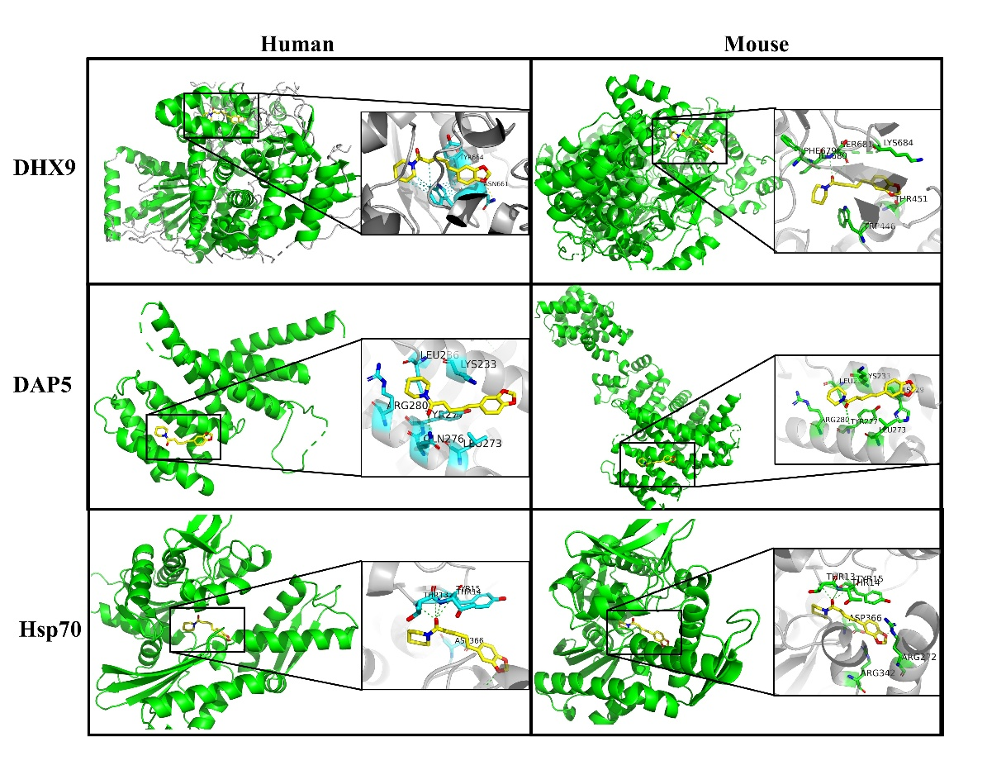
Figure 3. Molecular docking analysis of piperine with FXTAS-associated targets via 3D docking pose across human and mouse: DHX9; DAP5 and Hsp70. The columns correspond to the species (human and mouse).

